

**Community Engagement Quarterly Update**

**January - March 2023**

This update provides a summary of YAS’s community engagement activity for the period 1 January 2023 – 31 March 2023.

For more information contact the community engagement team: [yas.communityengagement@nhs.net](mailto:yas.communityengagement@nhs.net)

# Community Engagement Strategy objectives 2021 – 2024

* + Saving lives
  + Encouraging appropriate use of YAS services
  + Using our position as an anchor organisation to provide employment and training opportunities in our communities, and to support and strengthen them
  + Being responsive to the needs of our communities.

# Community Engagement priorities for 2022/23

* Engagement with homeless communities, people with a Learning Disability and vulnerable women
* Train-the-trainer programmes to expand the reach of our life-saving skills training
* Employability and skills support for those facing the greatest barriers to employment
* Events programme to provide visibility and build relationships with our communities.

# Summary of engagement in this period

There were 36 external community engagement events in this period. Engagement activity included first aid and Basic Life Support (BLS) training; engagement on YAS careers; employability and a number of public events.

Of the 36 events, 14 were delivered in areas within the 20% most deprived nationally. As well as events for the general public, we engaged with a range of communities experiencing poor health outcomes and needing support to access services, including:

* Black, Asian and Minority Ethnic communities
* Carers
* Vulnerable women.

**Appendix 1** provides a breakdown of community engagement activities by Integrated Care System (ICS) area; deprivation (based on the location of the activity) and populations targeted.

# Stakeholder and community engagement in this period

**Training community partners to be life savers**

In January we launched our Community Partners Programme, supporting staff, students and volunteers in community organisations and colleges to become Community Trainers.

Funded by YAS Charity, this programme provides equipment alongside a train-the-trainer course to give local organisations everything they need to teach others how to save lives in the event of an emergency.

We are creating Community Trainers in the following organisations:

|  |  |
| --- | --- |
| [Leeds City College](https://leedscitycollege.ac.uk/) | [Change Grow Live, Bradford](https://humankindcharity.org.uk/service/new-vision-bradford/) |
| [Hull CVS](https://hullcvs.org.uk/) | [East Riding Voluntary Action Services](https://ervas.org.uk/) |
| [The Moorlands Centre, Goole](https://www.facebook.com/moorlandscharity/?locale=en_GB) | [The SHoRes Centre, Withernsea](https://www.facebook.com/SHoResCentre/?locale=en_GB) |

**Public events**

Our public events programme continued through the last period. We hosted an event at the White Rose Centre in Leeds, with staff from our 999 and 111 call centres joining us to talk to the public about their roles.

We attended a number of our partners’ events, including a road safety event in Bradford and a Ladies Bazaar hosted by the [Peel Project](https://www.thepeelproject.org.uk/) in Hull.

**Supporting young people into employment with the Prince’s Trust**

In February we completed our third employability programme with the [Prince’s Trust](https://www.princes-trust.org.uk/), this time focused on supporting young people into 999 and 111 call handler roles.

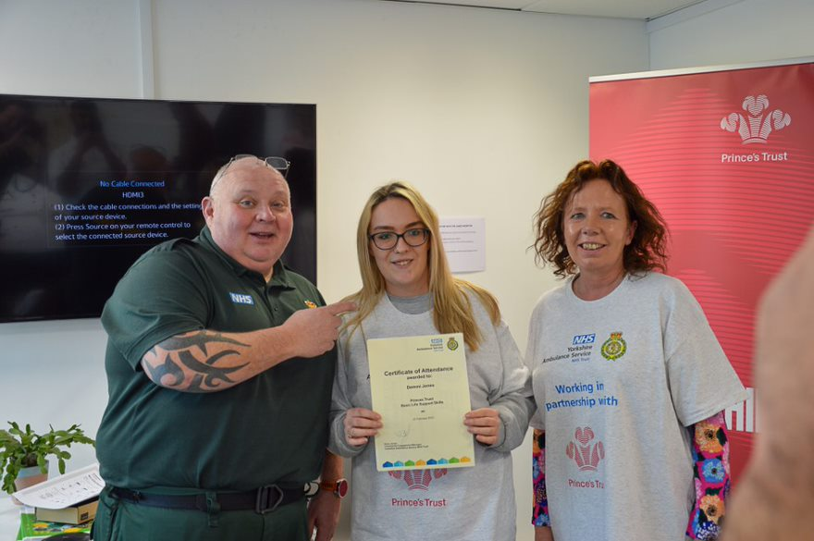

Participants met people from these services and took part in training exercises designed around the roles. A number of the participants are now progressing through recruitment to YAS call handler roles.

**Free first aid programmes**

We run a number of rolling five-week free first aid courses with community organisations. As well as courses for the general public, our current programmes include organisations that support black and minority ethnic communities; vulnerable women, deaf people and carers.

**Supporting programmes for young people**

We support a number of programmes that work with young people to raise aspirations and improve life chances, delivering first aid training or classroom-based activities.

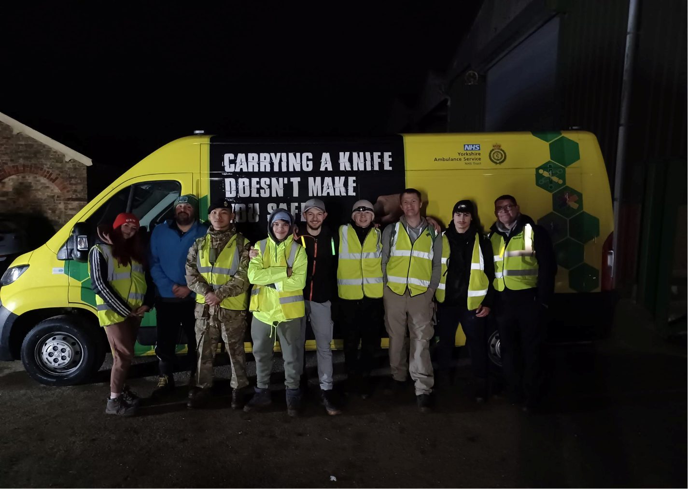

In March we delivered life-saving skills training as part of [West Yorkshire Police’s](https://www.westyorkshire.police.uk/) Aspire programme, which works with young people at risk of school exclusion.

March also saw us run life-saving skills training as part of [Humberside Police’s Night Challenge](https://www.humberside.police.uk/police-forces/humberside-police/areas/about-us/about-us/youth-engagement/), which takes young people through a number of challenging scenario-based exercises and runs overnight until the early hours of the morning.

**Working with our Community Engagement Volunteers**

In February we trained our second cohort of Community Engagement Volunteers (CEVs). Our CEVs are YAS staff or volunteers who wish to support community engagement, delivering training or education in their own communities.

We now have 26 CEVs registered to support community engagement activities.

**New Restart a Heart partnerships**

[The Resuscitation Council UK’s](https://www.resus.org.uk/) (RCUK) national [Restart a Heart](https://www.resus.org.uk/get-involved/restart-heart-day) campaign aims to increase the number of people trained in life-saving CPR. [This year will be the tenth that YAS has participated in the campaign](https://restartaheart.yas.nhs.uk/media/media-2023/celebrating-10-years-of-restart-a-heart-day/), recruiting volunteers to train thousands of school children across Yorkshire.

Over the last period we have developed new partnerships that will build on the success of Restart a Heart day by providing CPR training throughout the year under the campaign’s banner.

We have established a Restart a Heart society at Huddersfield University, which will enable students to volunteer to deliver CPR training and are planning a series of training events alongside [Kirklees Year of Music](https://www.musicinkirklees.co.uk/en-UK).

# Focus in the next period: April 2023 – June 2023

**Supporting people to improve their lives through ‘Achieve’**

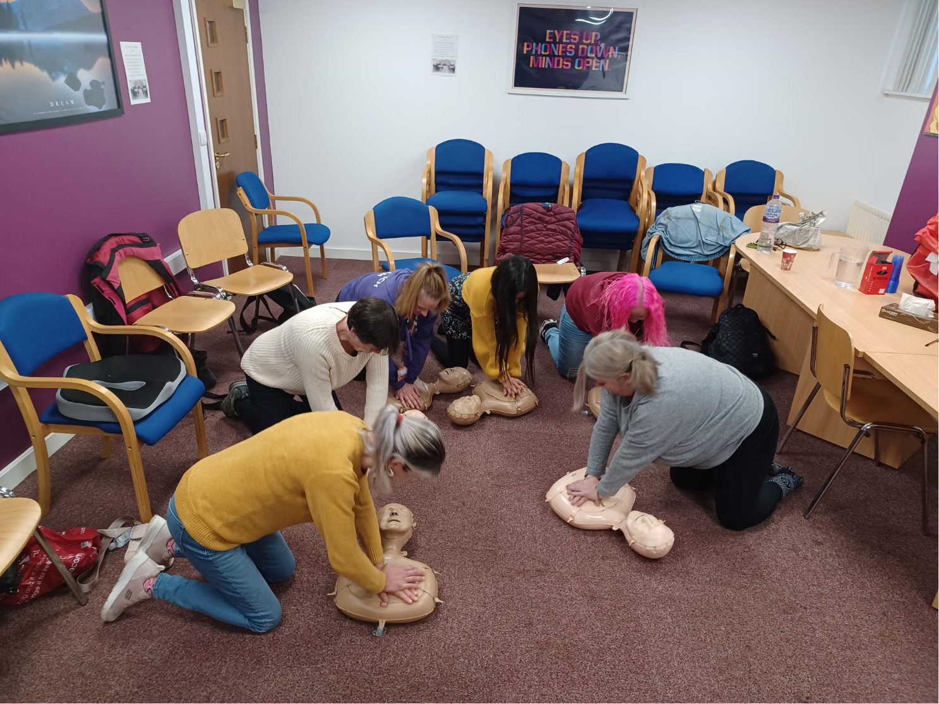Over the next period we will be expanding our Achieve programme, which provides practical life skills including first aid, team working and mental health resilience. Achieve partners with organisations that work with people who need support to improve their lives.

Our first Achieve course worked with people recovering from drug and alcohol addiction, partnering with Change Grow Live (CGL) Bradford. We have since run a women’s only group with CGL.

We are now expanding the programme to work with the Hull branch of CGL and will also be running a course with the Hull City Council VEMT team – working with vulnerable, exploited, missing and trafficked women.

Community Trainers to roll out their programmes

From May our Community Partners will be rolling out their own life-saving skills training. Providing training in their own communities or college, Community Trainers will contribute to 1,000 people receiving life-saving skills training across Yorkshire.

**Engaging the public at our roadshows**

Our roadshows continue in this period, with an event planned for Bransholme shopping centre in Hull.

# Appendix 1 - Summary of community events in this period

Location of events by ICS footprint

|  |  |
| --- | --- |
| **ICS location of event** | **No. of activities in ICS footprint** |
| WY | 27 |
| H&NY | 9 |
| SY | 0 |
| **Total events** | **36** |

Number of events by Index of Multiple Deprivation decile*

|  |  |
| --- | --- |
| **IMD Decile** | **No. of activities in IMD decile** |
| 1 | 12 |
| 2 | 2 |
| 3 - 10 | 22 |
| **Total events** | **36** |

*NHSE/I’s CORE20PLUS5 framework for health inequalities asks NHS organisations to prioritise the 20% most deprived areas for action to address health inequalities. The number of events within the 20% most deprived areas nationally are highlighted above.

Number of events by population/interest group targeted

| **Population/interest groups engaged** | **No. of activities with population group** |
| --- | --- |
| Further Ed | 6 |
| Primary school | 6 |
| Young people | 6 |
| General | 5 |
| Secondary school | 3 |
| BAME | 2 |
| Carers | 2 |
| Women | 2 |
| Older people | 1 |
| Mental health | 1 |
| Substance misuse | 1 |
| Disability | 1 |
| **Total events** | **36** |